SEI BE – Shift Reductions TD

Technical Design

13/05/2025

Contact:

Owner

Owner Email

Table of contents

Document Control 1

Document History 1

Transport Info 1

1. Introduction 2

2. Functional Design 3

3. Solution Details 4

3.1. Solution Subset 1 4

3.2. Solution Subset 2 4

Document Control

Document History

|  |  |  |  |
| --- | --- | --- | --- |
|  |  |  |  |
| **Version** | **Date** | **Author** | **Changes** |
| 1.0 | 13/05/2025 |  |  |
|  |  |  |  |
|  |  |  |  |

Transport Info

|  |  |  |
| --- | --- | --- |
| **RT** | **Transports** | **Comments** |
|  |  |  |
|  |  |  |
|  |  |  |

1. Introduction

Brief functional description of the work package.

1. Functional Design

In this section you should include the details or the reference to the functional document (Questionnaire, BBP, etc) with the requirements being implemented in this work package.

1. Solution Details

3.1 Map Hourly Rate

SPRO

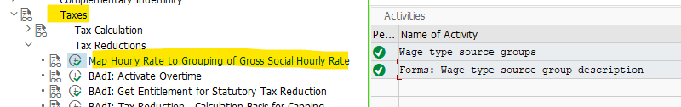

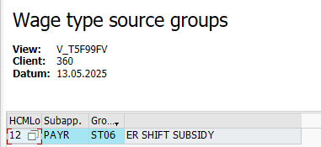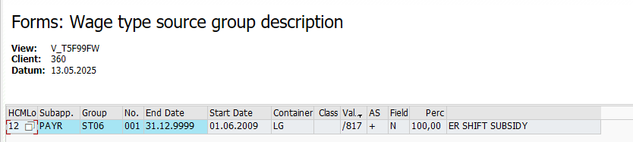

Creation of the Rule

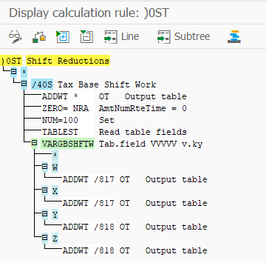

Introduction of the rule in the PY Schema

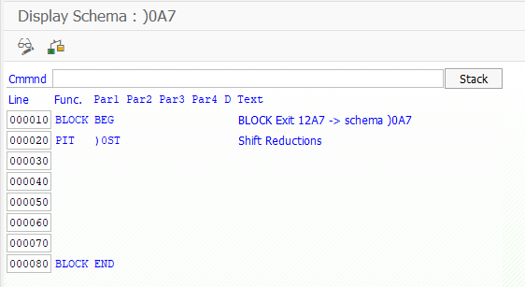

T511K

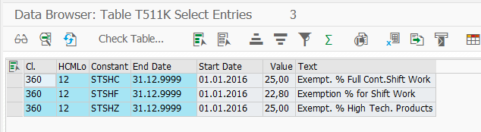

About Strada

Strada is a technology-enabled, people powered company committed to delivering world-class payroll, human capital management, and financial management solutions to organizations globally. With a team of more than 8,000 experts, Strada blends leading-edge technology with human ingenuity to help businesses across the globe design and deliver at scale. Supporting over 1,400 customers in 33 countries, Strada partners with customers at every stage of their journey, to help drive their vision forward.